VIETNAM GENERAL CONFEDERATION OF LABOR

**TON DUC THANG UNIVERSITY**

**FACULTY OF INFORMATION TECHNOLOGY**

**TOPIC**

**MANAGEMENT INFORMATION SYSTEM PROJECT**

*Instructing Lecturer*: **HỒ THỊ THANH TUYẾN**

*Student’s name*: **TRƯƠNG QUANG KHÔI** – 520H0546

**TRẦN CỰ PHÚ –** 520H667

**HUỲNH THANH DUY –** 519H0286

**NGUYỄN HỮU HOÀI BẢO –** 518H0599

**LÂM TRÍ THIỆN –** 520H0495

Course  **: 24**

**HO CHI MINH CITY, 2023**

VIETNAM GENERAL CONFEDERATION OF LABOR

**TON DUC THANG UNIVERSITY**

**FACULTY OF INFORMATION TECHNOLOGY**

**TOPIC**

**MANAGEMENT INFORMATION SYSTEM PROJECT**

*Instructing Lecturer*: **HỒ THỊ THANH TUYẾN**

*Student’s name*: **TRƯƠNG QUANG KHÔI** – 520H0546

**TRẦN CỰ PHÚ –** 520H0667

**HUỲNH THANH DUY –** 519H0286

**NGUYỄN HỮU HOÀI BẢO –** 518H0599

**LÂM TRÍ THIỆN –** 520H0495

Course  **: 24**

**HO CHI MINH CITY, 2023**

**THANK YOU**

Thanks for helping us and gave us knowledge to understand this course.

**THE REPORT WAS COMPLETED**

**AT TON DUC THANG UNIVERSITY**

I assure you that this essay is my own and under the instructions of lecturer Hồ Thị Thanh Tuyến. The content of research, results, source code in this report is honest and has not been published in any form before. The documents and reference sources for making the report, I will specify in the references section.

If any fraud is found, I am fully responsible for the content of my report. Ton Duc Thang University is not involved in any copyright infringement in the course of making this report (if any).

*Ho Chi Minh city, May 16th 2023*

*Author*

*(sign and write full name)*

*Trần Cự Phú*

*Trương Quang Khôi*

*Nguyễn Hữu Hoài Bảo*

*Huỳnh Thanh Duy*

*Lâm Trí Thiện*

**CONFIRMATION AND EVALUATION OF LECTURER**

**Confirmation for the instructor**

_____________________________________________________________________________________________________________________________________________________________________________________________________________________________________________________________________________________________

*Ho Chi Minh City, 2023*

*(Sign and write full name)*

**Evaluation of the grading lecturer**

_____________________________________________________________________________________________________________________________________________________________________________________________________________________________________________________________________________________________

*Ho Chi Minh City, 2023*

*(Sign and write full name)*

**Table of Contents**

**1. About the organization you approached** 3

**2. Analyze their existing information system** 6

- Analyze the industry structure and target market share pursued by the organization. 6

- Competitive strategy of the organization in each period from the present to the next 10 years 8

- Analyzing the business strategy of BaoViet company will aim for 10 years 9

- Value chain of the system, identify and analyze the main activities/support activities in the value chain that you consider most important. 9

- Analyze organization structure of 5 components of an information system: hardware, software, people, processes, and data. 11

**3. Organizational issues and requirements for the new information system** 12

**4. Proposal of a new system** 15

- General usecase diagram, ER Diagram 15

- Describe the changed/improved processes of the new system 16

- Analyze and evaluate what new changes/proposals meet/support for the organization&#39;s competitive strategy 17

**5. Evaluation, conclusion** 18

Pros and cons 18

**Your review** 18

**1. Lessons learned from the project** 18

**2. Your Source code** 18

**3. Your group meeting minutes** 18

**4. Video demo** 18

**5. Evaluate the members & contribution** 18

**List of Pictures**

*Picture 1: Organization chart 3*

*Picture 2: Life insurance premium collection market share in 2020 7*

*Picture 3: Proportion of revenue by insurance business in the first 10 months of 2021 7*

*Picture 4: usecase diagram of healthcare insurance ecomerce-webstie 15*

*Picture 5: ERD diagram of healthcare insurance ecomerce-webstie 16*

**Lis of Tables**

*Table 1: Primary and Support Activites 10*

*Table 2: Comparison about old and new insurance systems 14*

# 1. About the organization you approached

**- Objectives:**

Customers across the country who needs to use insurance, learn about insurance and associated services.

**- Mission:**

With a vision to change people's perception of insurance, our company's product is a differentiated, easily accessible insurance that brings customers new experiences, making the process of getting a single insurance policy easier, simpler, faster and easier with innovative solutions, easy to understand products powered by intelligent digital technology.

**- Size:**

Our company approaches customers in big cities then neighboring provinces.

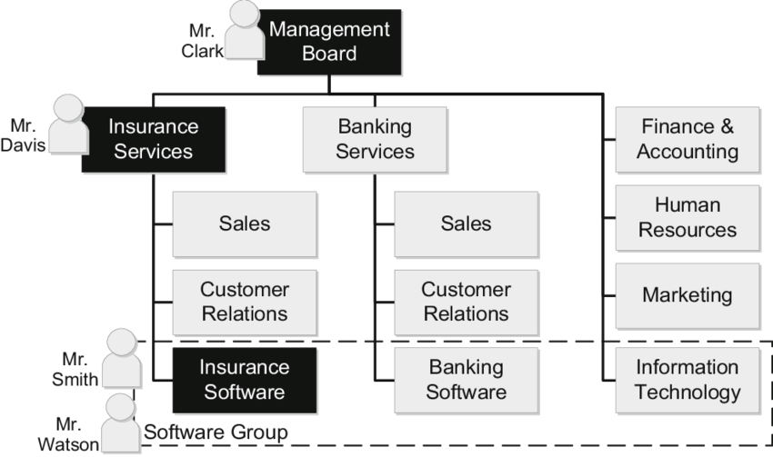

*Picture 1: Organization chart*

**Business area/Function…:**

**- Management:**

Managers are responsible for the work performance of other people. **Management** involves planning for, organizing, leading, and controlling a company’s resources so that it can achieve its goals.

**- Customer Service Function:**

* Answering customer inquiries about products and services
* Providing after-sales service, including replacing damaged goods, arranging for repairs or for spare parts to be obtained and fitted
* Analyzing records of customer complaints to resolve problem areas
* Using customer feedback to improve customer service and satisfaction

**- Sales Function:**

* Selling the product or service to customers, either over the telephone or face to face
* Providing technical advice
* Keeping customer records up to date
* Responding to customer inquiries

**- Finance Function:**

* Producing invoices, checking payments are received and chasing up overdue payments
* Recording money received
* Checking and paying invoices received
* Preparing the payroll and paying staff salaries

**- Marketing :**

* Marketers develop the benefits and features of products, including price and quality. They also decide on the best method of delivering products and the best means of promoting them to attract and keep customers. They manage relationships with customers and make them aware of the organization’s desire and ability to satisfy their needs.
* Promoting products and services through a variety of advertising and promotional methods, e.g., press, TV, online, direct mail, sponsorship, and trade shows or exhibitions
* Obtaining and updating a profile of existing customers to target advertising and promotions appropriately
* Carrying out market research to obtain feedback on potential and existing products and/or services
* Designing, updating and promoting the company website

**- Information Technology:**

* Recommending new/updated systems and software to keep abreast of technological developments and the needs of the business
* Buying and installing new hardware and software and providing information or training as appropriate
* Assisting users who have computer problems
* Repairing the computer system when required
* Connecting new or additional equipment to the system

**- Human Resources:**

1. Advertising job vacancies
2. Notifying staff of promotion opportunities
3. Receiving and recording all job applications, arranging interviews and notifying candidates of the result
4. Sending a contract of employment and other essential information to new staff
5. Arranging staff training and encouraging continuous professional development
6. Monitoring the working conditions of staff
7. Checking health and safety and keeping accident records

**2. Analyze their existing information system**

**- Analyze the industry structure and target market share pursued by the organization:**

* Market: The organization operates in the insurance industry, which is a competitive and regulated sector that offers various types of insurance products and services.
* Competitors: Within the insurance industry, there are likely multiple competitors offering similar insurance and related services. These competitors may include large insurance companies, regional insurers, and niche providers.
* Products and Services: The organization offers insurance products and associated services to meet the needs of its customers. The specific types of insurance coverage and services provided would depend on the organization's focus and offerings, which can include life insurance, health insurance, property insurance, vehicle insurance, etc.
* Target Market Share Pursued: The organization aims to achieve a significant market share within the insurance industry. By pursuing a substantial market share, the organization seeks to establish itself as a major player and generate a notable portion of the industry's total revenue. This objective reflects the organization's ambition to become a prominent and influential force in the insurance market.
* Geographic Reach: The organization aims to serve customers across the entire country, indicating a national or widespread target market. By positioning itself as a nationwide insurance provider, the organization likely aims to capture a significant share of the market.
* Customer Segments: The organization targets customers who have a demand for insurance and are interested in learning more about insurance products and related services. This could include individuals, families, businesses, and potentially other entities.
* Market Share Objective: The organization likely seeks to gain a substantial market share within the insurance industry, aiming to attract a significant number of customers and generate a notable portion of the industry's total revenue

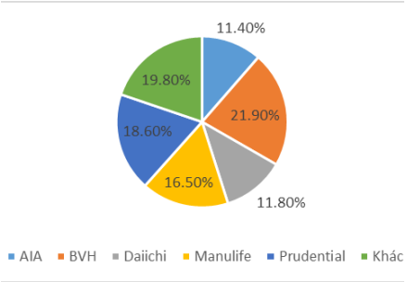

*(Source: Insurance Administration and Supervision Department)*

*Picture 2: Life insurance premium collection market share in 2020*

*The insurance market in Vietnam is mainly in the hands of large companies such as BVH (21.90%), Prudential (18.60%)….*

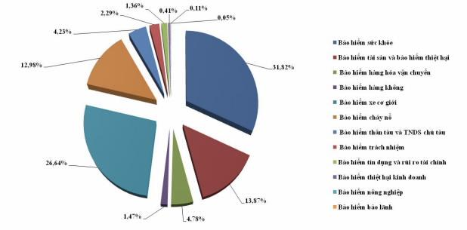

*(Source: Department of insurance management and supervision)*

*Picture 3: Proportion of revenue by insurance business in the first 10 months of 2021*

*Leading the way is health insurance (31.82%) and motor vehicle insurance (26.64%), liability insurance (13.87%).*

**- Competitive strategy of the organization in each period from the present to the next 10 years**

* Market: The organization operates in the insurance industry, which is a competitive and regulated sector that offers various types of insurance products and services.
* Competitors: Within the insurance industry, there are likely multiple competitors offering similar insurance and related services. These competitors may include large insurance companies, regional insurers, and niche providers.
* Products and Services: The organization offers insurance products and associated services to meet the needs of its customers. The specific types of insurance coverage and services provided would depend on the organization's focus and offerings, which can include life insurance, health insurance, property insurance, vehicle insurance, etc.
* Target Market Share Pursued: The organization aims to achieve a significant market share within the insurance industry. By pursuing a substantial market share, the organization seeks to establish itself as a major player and generate a notable portion of the industry's total revenue. This objective reflects the organization's ambition to become a prominent and influential force in the insurance market.
* Geographic Reach: The organization aims to serve customers across the entire country, indicating a national or widespread target market. By positioning itself as a nationwide insurance provider, the organization likely aims to capture a significant share of the market.
* Customer Segments: The organization targets customers who have a demand for insurance and are interested in learning more about insurance products and related services. This could include individuals, families, businesses, and potentially other entities.
* Market Share Objective: The organization likely seeks to gain a substantial market share within the insurance industry, aiming to attract a significant number of customers and generate a notable portion of the industry's total revenue

## - Analyzing the business strategy of Baoviet company will aim for 10 years:

* Find and increase market share by exploiting target market => Market penetration strategy
* Expansion of exploitation to other customers outside the current target market => Market development strategy
* Create products that are different from other businesses => Differentiation strategy
* Develop product types to limit risks => Diversification strategy

**- Value chain of the system, identify and analyze the main activities/support activities in the value chain that you consider most important:**

* Underwriting and Risk Assessment: This activity is crucial because it forms the foundation of the insurance business. Accurate risk assessment helps determine appropriate coverage and premium rates, ensuring that the organization maintains profitability and manages risk effectively.
* Marketing and Sales: Effective marketing and sales activities are essential for attracting and acquiring customers. By understanding customer needs, conducting market research, and implementing targeted marketing strategies, the organization can effectively communicate the value of their insurance products and services and increase their customer base.
* Claims Management: Efficient and customer-centric claims management is critical for maintaining customer satisfaction and loyalty. A streamlined claims process, timely settlement, and effective communication with policyholders during the claims journey are key factors in ensuring a positive customer experience.
* Customer Service: Providing excellent customer service throughout the customer lifecycle is vital for building strong relationships and retaining customers. Promptly addressing inquiries, providing support, and offering personalized assistance can help differentiate the organization from competitors and foster long-term customer loyalty.
* Information Technology (IT): In the digital age, robust IT infrastructure and digital platforms are essential for efficient operations and delivering a seamless customer experience. Investing in IT systems, data management, and user-friendly digital interfaces can improve internal processes, enhance customer interactions, and enable data-driven decision-making

| **Primary Activites** | | | | |
| --- | --- | --- | --- | --- |
| Product and service | Marketing and sales | Policy Administration | Claims/Benefits Manager | Asset Manager |
| + New products  + Product manager  + Delivery channels  + Research  + Prevention and migration | + Promotion  + Target Markets  + New customers  + Cross selling  + Up selling | + Transcation Processing  + Payment | + Claims Submissions  + Claims Settlement  + Payment  + Fraud | + Portfolio  + Managerment  + ALM  + Risk Analytics |
| **Support Activites** | | | | |
| + Data Analytics  + Company Infrastructure(Finace, IT, Risk manager)  + Reinsurance  + Human Resources Management | | | | |

*Table 1: Primary and Support Activites*

**- Analyze organization structure of 5 components of an information system: hardware, software, people, processes, and data.**

* Hardware: The hardware component of the organization's information system includes physical devices such as computers, servers, networking equipment, and other devices used to support the processing and storage of data. This may include desktop computers, laptops, servers for data storage, routers, switches, and other network infrastructure.
* Software: The software component encompasses the applications, programs, and operating systems used by the organization to process and manage data. In the insurance industry, this may include specialized insurance software for policy management, claims processing, underwriting, customer relationship management, and data analytics. It can also involve standard office productivity software like word processors, spreadsheets, and email clients.
* People: The people component refers to the individuals who interact with and use the organization's information system. This includes employees, managers, IT staff, and end-users who rely on the system for their daily tasks and decision-making processes. In the insurance industry, this may involve underwriters, claims processors, customer service representatives, IT support personnel, and executives.
* Processes: The processes component involves the procedures, workflows, and rules that govern how data is collected, processed, stored, and disseminated within the organization's information system. In the insurance industry, this includes the processes for policy issuance, underwriting, claims management, customer service, data entry, data validation, data backup, and security protocols.
* Data: The data component represents the structured and unstructured information that is used and generated by the organization's information system. In the insurance industry, this includes customer data, policy information, claims data, financial data, risk assessment data, and other relevant data points. This data is the foundation for decision-making, analytics, reporting, and other activities within the organization.

**3. Organizational issues and requirements for the new information system**

The existing problems of the old insurance system need to be addressed to improve the overall performance of the new system. These problems may arise from different components such as processes, data, hardware, or software. Without additional information, it's difficult to provide specific examples of the old insurance system. However, in general, an old insurance system might have been a legacy software application running on outdated hardware, relying on manual processes and outdated workflows. The system might have had limited automation capabilities, lacked real-time data analytics, and might have been difficult to integrate with other systems or third-party applications. Customers might have had limited access to self-service tools or online portals, and claims processing times could have been slow and error-prone.

Some common issues that insurance systems face include:

* Inefficient processing of claims: This could be caused by outdated hardware, inadequate software architecture, or a lack of integration between different systems. Claims processing may take longer than necessary, leading to customer frustration and dissatisfaction.
* Poor customer service: This could be caused by a lack of self-service options, slow response times, or limited access to policy information. Customers may experience long wait times or have difficulty reaching a representative, leading to frustration and dissatisfaction.
* Lack of integration with other systems: This could result in data silos, where information is not shared effectively between different systems. This can cause delays and errors in processing requests, leading to customer frustration and inefficiencies in the system.
* Security vulnerabilities: The old system may have had weaknesses in its design or lack of proper security protocols, leaving it open to potential data breaches or other security threats.

A thorough analysis of the old system can identify these problems and help design the new system to overcome them. The expected goals of the new system include improved efficiency, increased customer satisfaction, reduced costs, and improved regulatory compliance. The new system should address the problems of the old system and provide a better experience for customers and employees. The expected goals of the new insurance management system would depend on the specific needs and requirements of the organization. Some possible goals of the new system could include:

* Improved efficiency: The new system may be designed to streamline processes and automate tasks, reducing the time and effort required to manage insurance policies and claims. This could involve upgrading hardware, improving software architecture, or implementing new technologies such as machine learning and artificial intelligence.
* Better customer service: The new system may include features that improve customer experience, such as online access to policy information, self-service options, and faster claims processing. This could involve upgrading the user interface, implemen zting chatbots or other automated tools, or providing more comprehensive customer support.
* Enhanced security: The new system may be designed with robust security measures to protect sensitive customer data and prevent unauthorized access. This could involve implementing data encryption, multi-factor authentication, or other security protocols.
* Increased scalability: The new system may be designed to accommodate the needs of a growing customer base and expand to handle larger volumes of data and transactions. This could involve upgrading hardware, optimizing software architecture, or implementing cloud-based technologies.

Comparison between Old and New Insurance System in Viet Nam:

|  | Old Insurance System | New Insurance System |
| --- | --- | --- |
| Processes | Reliance on manual processes and paperwork, leading to delays in claims processing, policy issuance, and customer service | Increased automation and streamlined processes for faster operations and improved efficiency |
| Technology | Outdated technologies and limited access to real-time data analytics, hindering informed decision-making | Integration of advanced technologies and real-time data analytics for better insights and proactive decision-making |
| Customer Experience | Limited online presence and self-service options resulting in inconvenience and restricted access to services | resulting in inconvenience and restricted access to services resulting in inconvenience and restricted access to services |
| Security | Vulnerabilities in data security and lack of robust measures for protecting sensitive customer information | Implementation of robust security protocols, encryption, and access controls to ensure data protection |
| Efficiency | Slow operations and delays in claims processing and policy issuance | Streamlined processes, reduced turnaround times, and improved accuracy through automation |
| Competitiveness | Limited competitiveness due to outdated systems and processes | Enhanced competitiveness through advanced technology, improved efficiency, and better customer experience |
| Growth and Innovation | Limited scope for innovation and keeping up with industry trends | Embracing digital transformation, enabling continuous growth and innovation |

*Table 2: Comparison about old and new insurance systems*

In conclusion, the old insurance system may have had various issues, ranging from inefficient processes to security vulnerabilities. The new insurance system aims to address these issues by improving efficiency, customer service, security, and scalability. To achieve these goals, the new system may require upgrading hardware, optimizing software architecture, implementing new technologies, and providing more comprehensive customer support. By doing so, the new insurance system can offer a better experience for both customers and employees and help the organization achieve its goals more effectively. It's important to note that the requirements and goals of the new system may vary depending on the organization's needs and priorities. Therefore, a thorough analysis of the old system and the organization's requirements is essential to design an effective and efficient insurance management system.

**4. Proposal of a new system**

**- General Usecase diagram:**

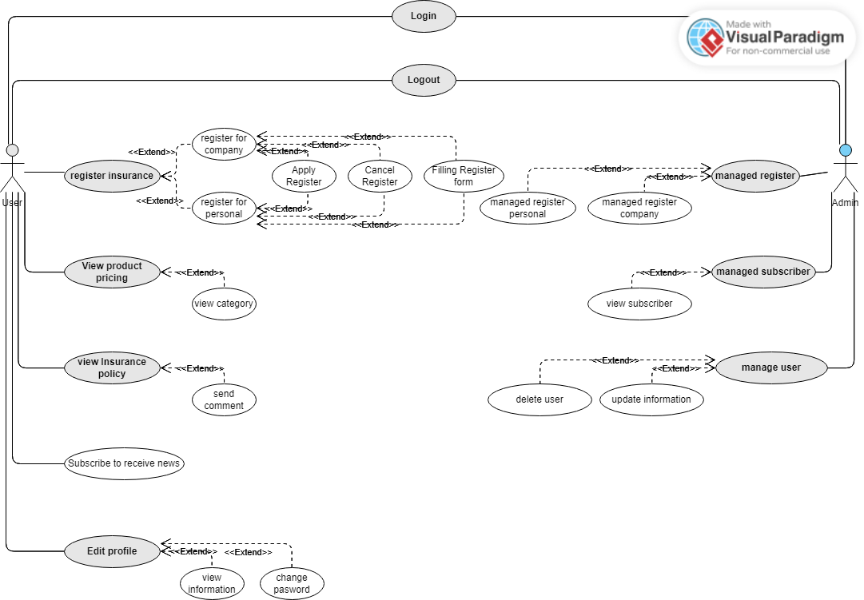

*Picture 4: usecase diagram of healthcare insurance ecomerce-webstie*

**- ERD Diagram:**

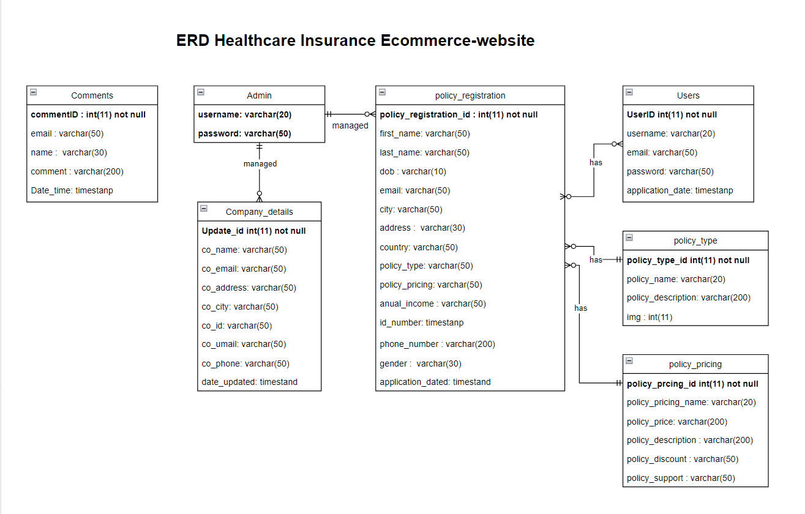

*Picture 5: ERD diagram of healthcare insurance ecomerce-webstie*

**- Describe the changed/improved processes of the new system:**

* Easy to see and easy to use interface for customer to register, managed account,
* Easy to see and easy to use interface for admin to Managed register and data of customer.
* Design professional websites with SEO standards to easily optimize and put the company's products and services on the TOP of google search.
* Increase the speed of interaction and service of the website to customers
* Create more new features such as multi-channel multi-connection support system, customer support chatbot system....
* Enhance security, ensure customer information, internal information to avoid leakage and damage.
* Improve administration, create more storage systems, analyze data, support analysis and support making reasonable business strategies

- **Analyze and evaluate what new changes/proposals meet/support for the organizations competitive strategy.**

- Our organization comeptitive strategy is strengthen customer and supplier intimacy.

- We use information systems to develop strong ties and loyalty with customers and suppliers Increase switching costs by:

* Enhance the interaction in E-comerece website by easy-to-see and easy-to-use interface, easy to attract new potetial customers.
* We get private customer information through website and help user to meet their goal or introduce more suitable product to customer by one-by-one supporting. From this we will develop strong ties and loyalty with customers and suppliers
* We making an easy interactive interfal for staff to easy tracking customer information, having good customer care and bonding the customer intimacy.

**5. Evaluation, conclusion**

**Pros and cons**

**Pros:**

+ Easy to use interface

+ Easy to modify database

+ Having enough basic functions

**Cons**

+ Many advanced functions and support are not available yet

+ Database may not secured

## Your review

### Lessons learned from the project

We learn how to manage various information systems so that they best serve the needs of managers, staff and customers. We also learn how to create systems for finding and storing data and they learn about computer databases, networks, computer security and lots more. For example, our project could use a computer database to keep track of which products sell best. And Our could use a database to sell insurance over the Internet.

### 2. Your Source code

https://drive.google.com/drive/folders/1lEA0gZrbMLtB1eqTy2gYSIZDJex74mCY?usp=sharing

### 3. Your group meeting minutes

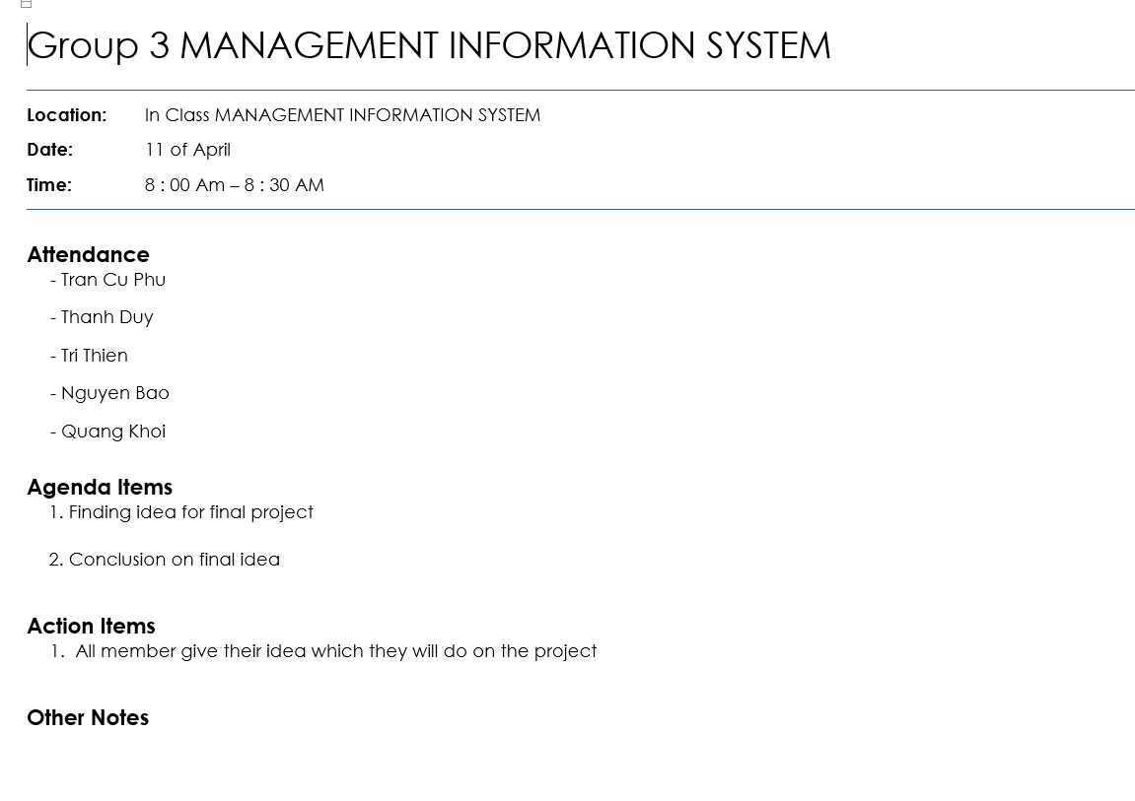

*Picture 6: group meeting minutes 1*

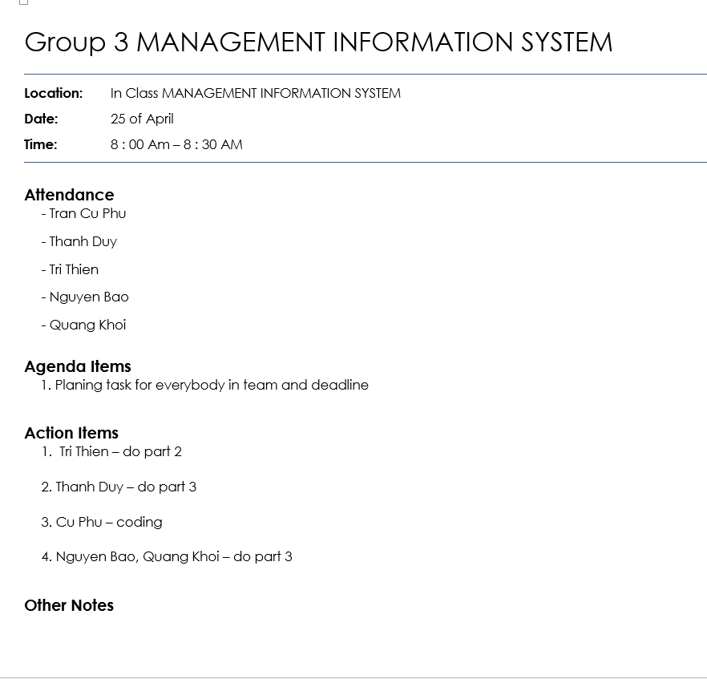

*Picture 6: group meeting minutes 2*

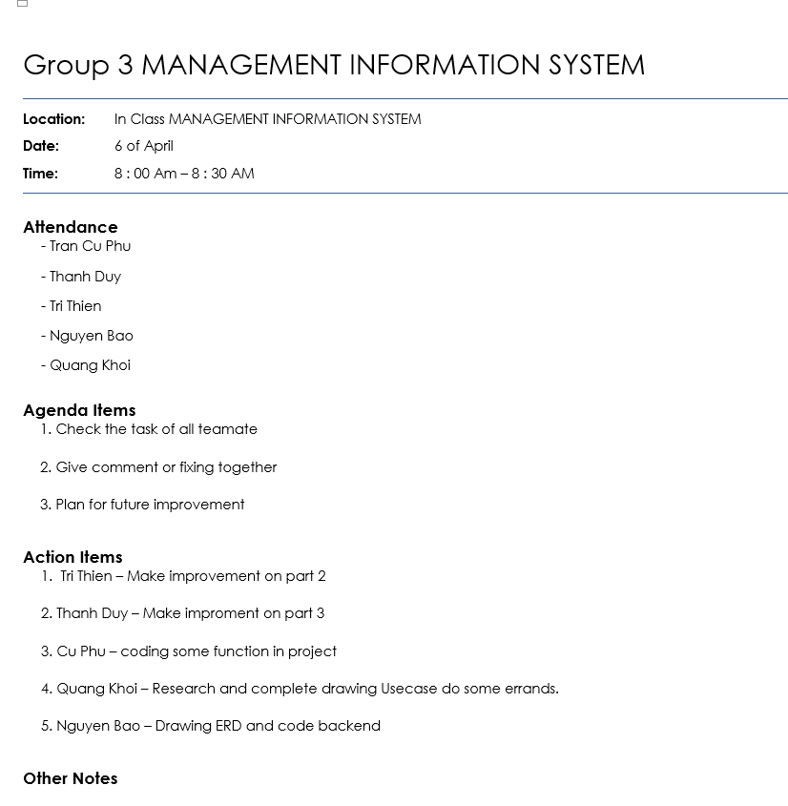

*Picture 6: group meeting minutes 3*

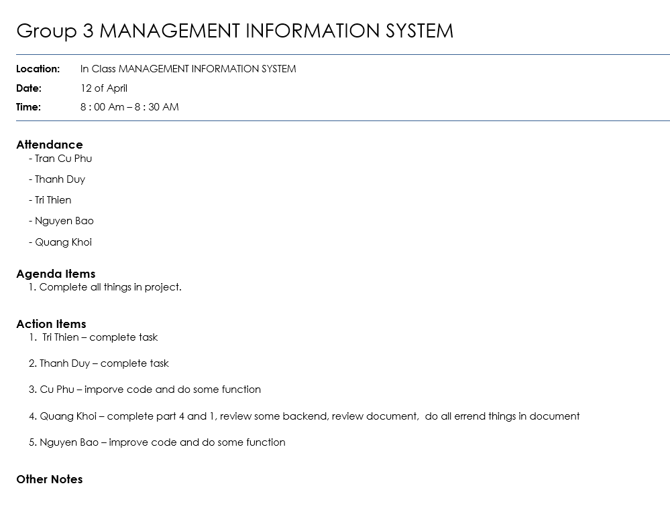

*Picture 6: group meeting minutes 4*

### 4. Video demo

https://drive.google.com/drive/folders/1lEA0gZrbMLtB1eqTy2gYSIZDJex74mCY?usp=sharing

### 5. Evaluate the members & contribution

| **Member’s Contribution** | |
| --- | --- |
| **Name** | **Contribution** |
| Trần Cự Phú (leader) | + Code interface  + Improve code  + Add some new function |
| Trí Thiện | + Do part 2 |
| Thanh Duy | + Do part 3  + Support document |
| Trương Quang Khôi | + Do Part 4 and 1  + Do half of part 2  + Support coding  + Do document, do powerpoint and other remaining things |
| Nguyễn Bảo | + Support coding  + Do part 4 |